# **CTF Challenge: Investigating IP - Using Dnslytics**



# **1. Introduction**

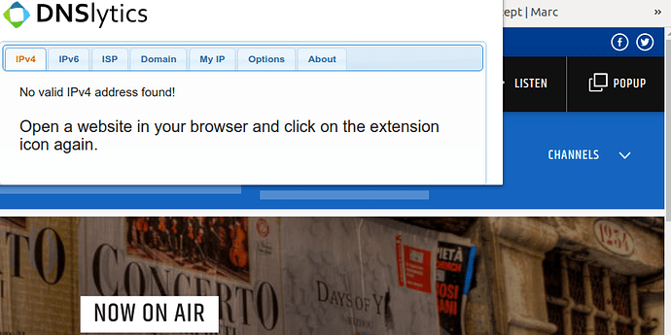

Dnslytics provides tools for DNS lookup, IP address information, ASN information, and more. This challenge will introduce you to using Dnslytics to gather DNS-related information about a target domain.

# **2. Tools and Requirements**

Access to the internet and Dnslytics

# **3. Scenario**

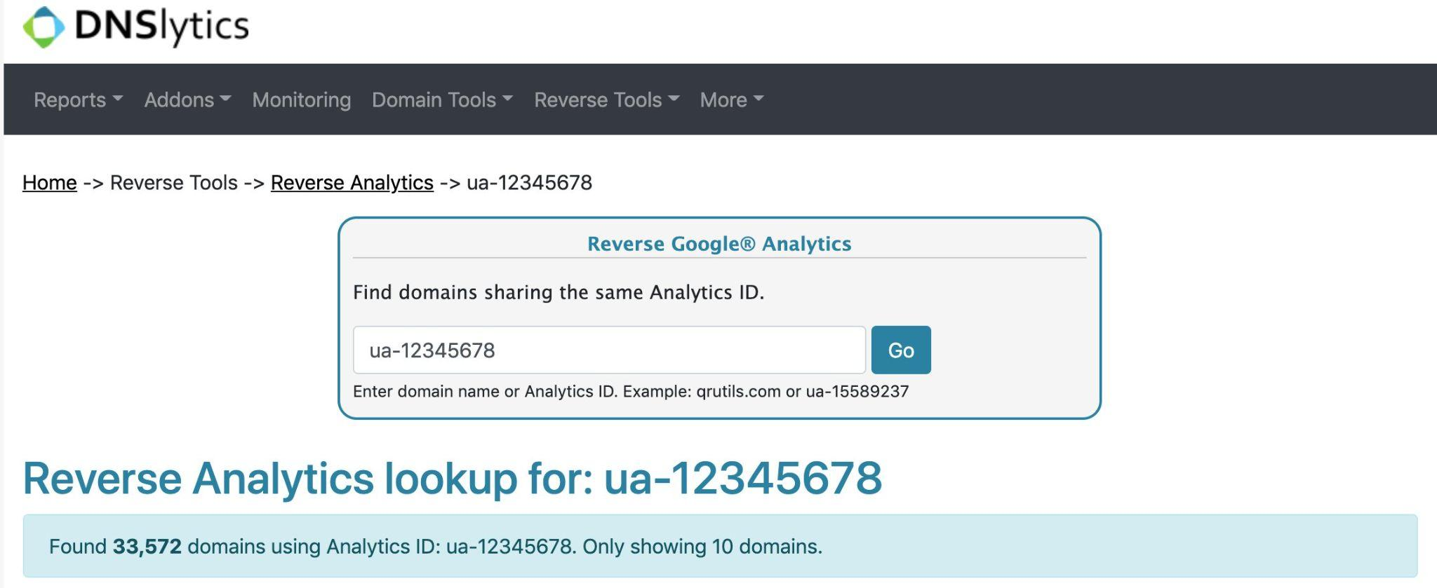

You are an ethical hacker tasked with assessing the DNS configuration of a target domain using Dnslytics. Your job is to find the total number of DNS records and identify one mail server (MX) record.

# **4. Process to follow while performing CTF**

Step 1: Visit Dnslytics:[**https://search.dnslytics.com/**](https://search.dnslytics.com/) Navigate to the Dnslytics website.

Step 2: Enter the Ipv6 address **2607:f8b0:4005:811::200e** in the search bar and initiate the lookup.

Step 3: The results will display various DNS records including A, AAAA, MX, TXT, and more.

Step 4: Solve the CTF.

# **5.Let’s Begin the Challenge**

**Question**

**Flag 1: What is the IP Location?**

*Answer: US* ***OR United States***

**Flag 2: How many Numbers of Domains have been hosted?**

Answer: 1

**Flag 3: How many Numbers of Mail servers have been hosted?**

Answer:0

Hint

